What’s New

# January 2012

The following items have been changed or added to TOTAL Planning Suite. Please review the “Release Notes” for a list of all changes. This document highlights features that have been moved or added to menus, new reports or other items where a visual review will be helpful.

**Inherited IRAs:**

On the Asset Details screen there is now a Retirement Plan Type option for Inherited IRAs. The first thing to be aware of is that for now there is a limit of only one Inherited IRA per individual.

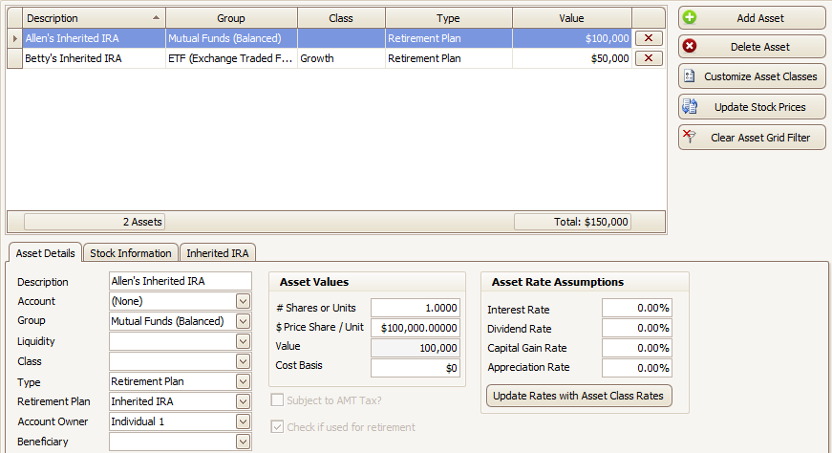

Once you select Inherited IRA as the type of retirement plan a new tab called the Inherited IRA tab will appear in place of the Monthly Additions/Withdrawals tab.

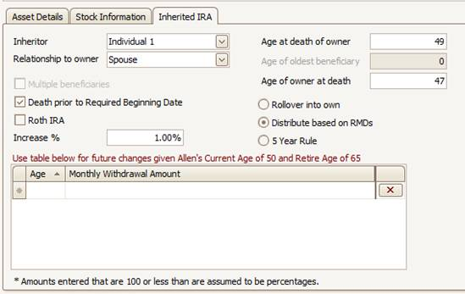Within this tab you will enter most of the information relevant to Inherited IRAs, however make sure to enter the value of the account, and the rate of return on the main Asset Details screen. Enter who inherited the IRA, what the relationship to the previous owner was, the inheritor’s age at the death of the owner (which allows you to future or post-date), the three options on the left, and the type of distributions you would like the program to assume. You will notice certain options are only available in specific cases.

To schedule withdrawals above and beyond the RMD, or to schedule the withdrawals for the 5 year rule you can use the Age Change Table provided. Note you can add an increase rate to scheduled withdrawals, and any amount entered that is equal to or less than 100 will be read as a percent, not as a dollar amount.

There are two new reports in Easy Money and Golden Years, each one covering the Inherited IRA of one individual. In Easy Money these are reports H9 and H10 in the appendix [note that this moved the Retirement Plan Summary to page H11]. In Golden Years these are reports C12 and C12a [note that this moved the Retirement Plan Summary to C13 while the Roth reports were moved to C11 and C11a]. A footnote on the Inherited IRA report page will note which options were selected for projecting the distributions from the account.

Specifics to be aware of:

IRA inherited by Spouse:

* If the Rollover into Own option is selected then the Inherited IRA report page will still show this account, but it will be treated as if it belonged to the inheritor, including Roth accounts not taking RMDs.
* If the RMD option is selected you will need to enter the Age of the Owner at death so that the program can correctly start taking RMDs at the age the original owner would have turned 70.

IRA inherited by Multiple Beneficiaries:

* Enter the age of the oldest beneficiary if there are multiple beneficiaries so that the reports can correctly calculate the RMD divisor based on that individual’s age.

# January 2011

The following items have been changed or added to TOTAL Planning Suite. If you review the “Release Notes” document, you will find many more items, but this document highlights features that have been moved or added to menus, new reports or other items where a visual review will be helpful.

**Introduction Screen:**

Upon opening TOTAL Planning Suite 5.0 for the first time, the new Introduction Screen which will walk you through adding, converting or connecting to a database as well as setting up a login for your database.

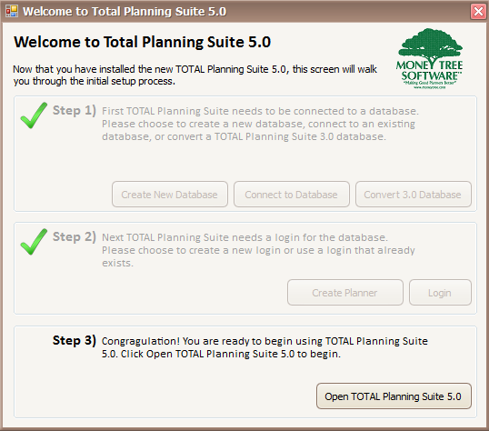

Anyone new to TOTAL Planning Suite will simply choose Create New Database in Step 1, and Create Planner in Step 2. Step 1 will ask you to name the database and choose a location for it. Step 2 will ask for information about the planner, as well as user name and password. Step 3 will then launch the program for the first time, which will start by asking you to login. Every time that you open the program after this you will only see the Login Screen.

For those who have used TOTAL Planning Suite before, the first advisor in an office to open TOTAL Planning Suite should Convert the database from use for version 3.0 to use for version 5.0. This will create a backup of the database before starting the conversion process just in case an error interrupts the conversion.

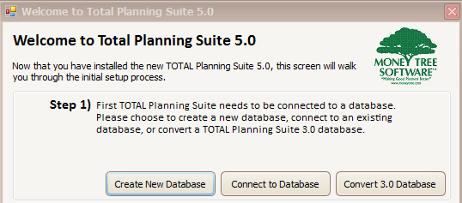Anyone who has already converted the 3.0 database, or has a co-worker who has already converted the database will simply need to Connect to the new database. For this you only need to know where the new database is located. It will have a file extension of .vtdb4, and if being shared within an office will likely be on a network drive. **This is very important, if one person in an office converts a database and another person converts the same database, the two will be working in separate databases from that point forward. Money Tree suggests having one person convert the database and everyone else in the office simply connect to the created database.**

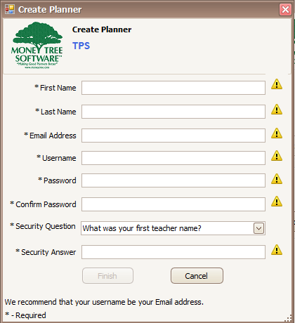

After converting or connecting to your database you will likely need to create a login. You will only be able to go straight to the login screen if you either had a login setup in TOTAL Planning Suite 3.0, or if have had an administrator set up a login for you in the new database before the first time you connect.

**Client List:**

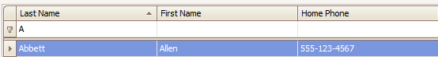The Client List has many additions which will be useful for advisors with large databases. One main addition is text filters which are shown as a line above the first client. By typing into these text boxes the list will automatically filter to show matching clients.

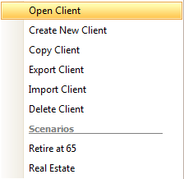

Right clicking on a client will bring up a menu with the options available for an individual client. This will make getting into a client’s scenarios quicker.

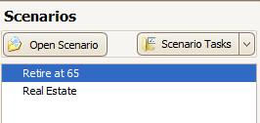

Another way to enter a scenario more quickly is to use the Scenarios list on the right of the Client List screen. Double clicking a scenario will open that scenario to the Assumptions input.

**Tools - Settings / Defaults:**

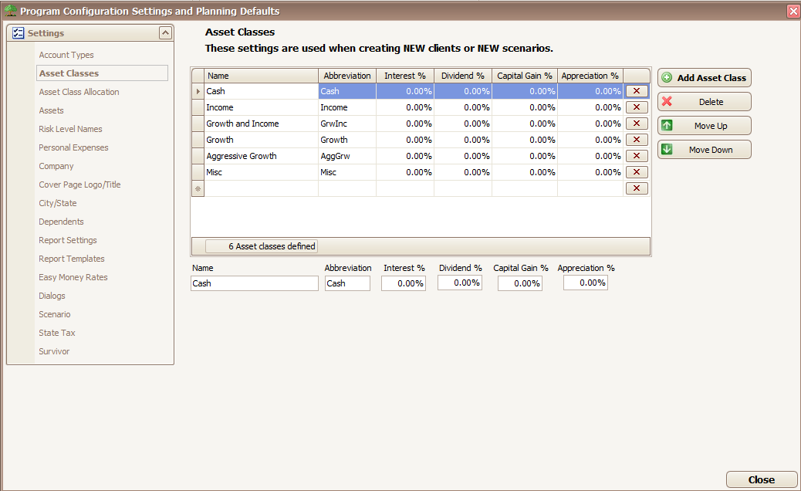All Settings/Defaults now have individual screens instead of a few of them having tabs within the screen (ie Asset Classes and Asset Class Allocation are now separate).

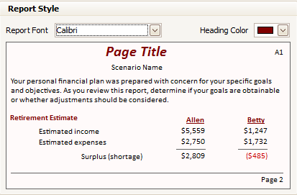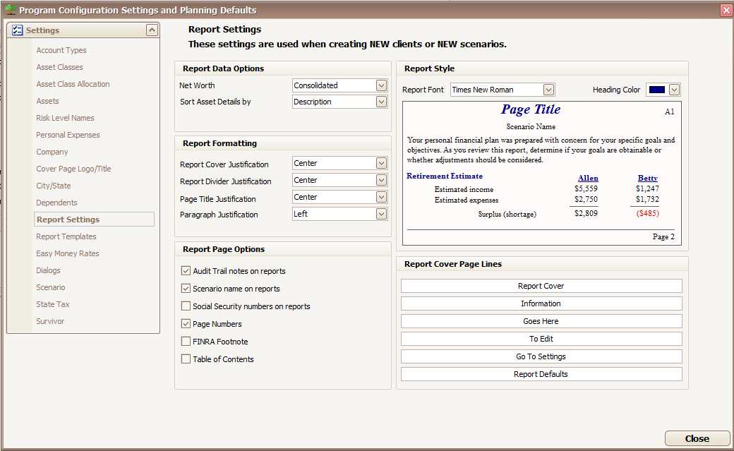Report Settings now allows the choice of color for header text, as well as the font style for the entire report. 15 fonts are available to replace the traditional Times New Roman of Money Tree reports. As you update your settings for reports an example of what the report will look like shows on the screen.

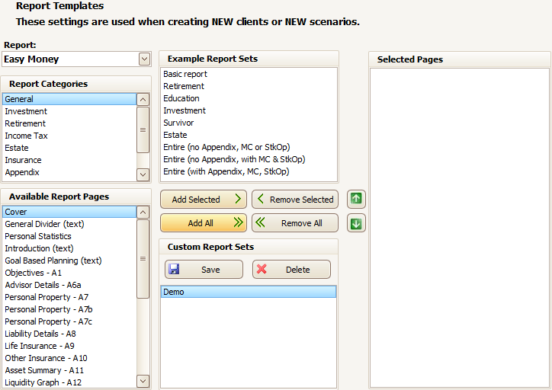Report Templates are now set up BEFORE running a report. The chosen report pages are the only pages that will show in the report and are all of the pages that will print, or save in the PDF if exported.

To select which Report Set is being set up select the appropriate report from the Report drop-down list.

Other than the above changes, this works exactly like the TOTAL Planning Suite 3.0 report customization.

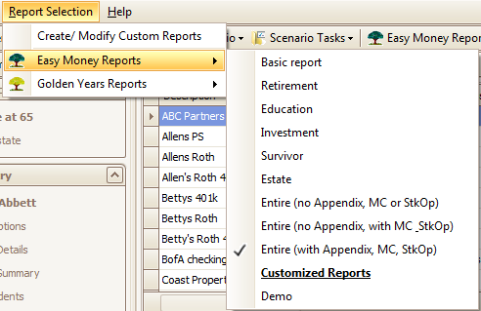In order to select which customized report template will be the one to run when the Easy Money or Golden Years report button is selected go to the “Report Selection” menu and under either Easy Money or Golden Years select the desired report set. You will then see a checkmark next to the selected report.

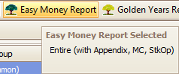Then when you hover the mouse over the Easy Money Report or Golden Years Report buttons a help box will show you which report will run when   
this button is selected.

**Assumptions**

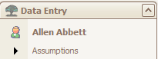The Assumptions section of input has been moved around so that there are no sub-tabs that could go unnoticed by advisors. Following are notes about the new locations of each input that has moved.

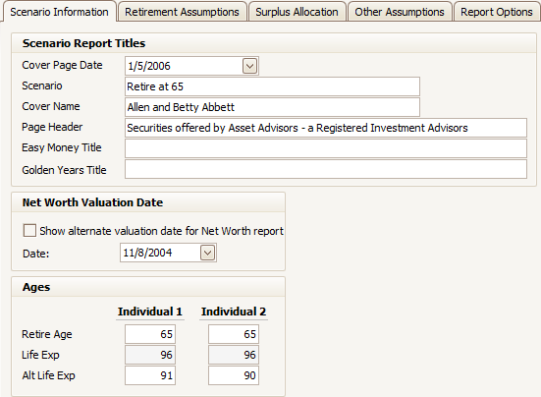

Net Worth Valuation Date has moved from Assumptions – Other Rates to Scenario Information

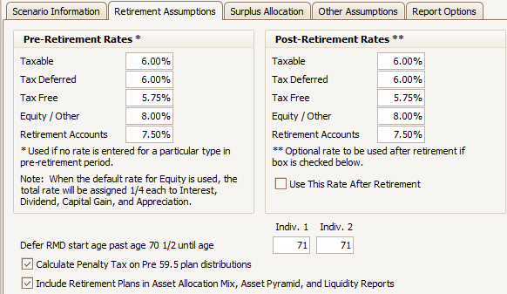

The Retirement Assumptions tab was moved up to be a main tab instead of a sub-tab under Assumptions.

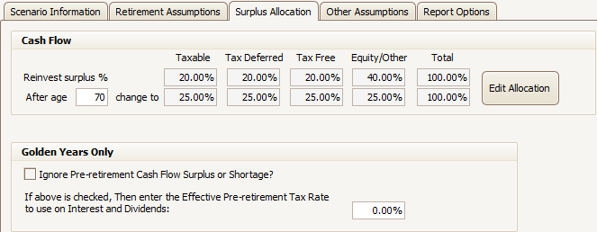The Assumptions – Misc. tab is now the Surplus Allocation tab.

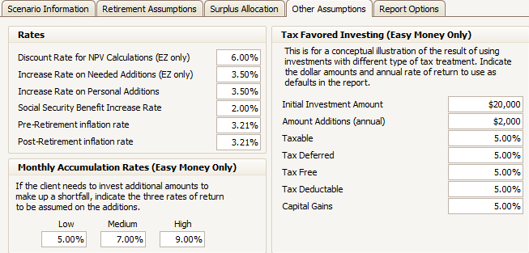Other Rates is now Other Assumptions and has Tax Favored Investing (Easy Money Only) and Monthly Accumulation Rates (Easy Money Only) which were previously on Report Options.

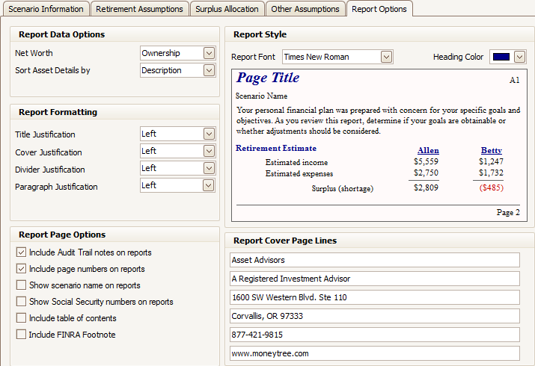

Report Options now has the option to Show Social Security numbers on reports, Include table of contents, and Include FINRA Footnote which were previously on the Print Selections screen. It also has the new Report Style section. All of these options will only affect the current scenario if changed here. To change for future clients and scenarios change these through Settings/Defaults in Report Settings.

**Assets:**

Asset Details has now been split so that there are no longer sub-tabs in the Assets section. All tabs dealing with the entry of individual assets are now in the Asset Details section while all other tabs are under Asset Summary.

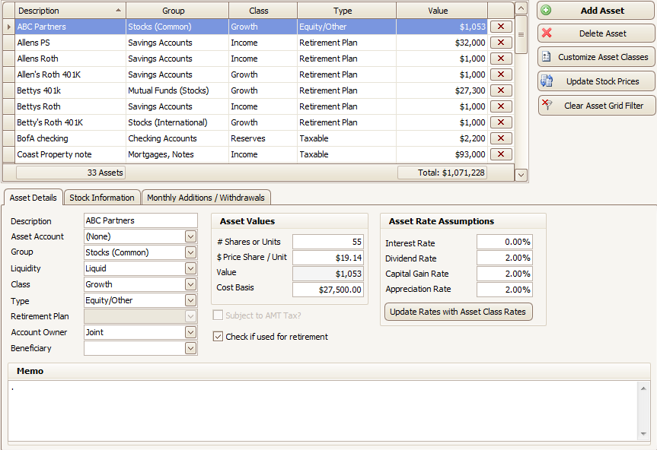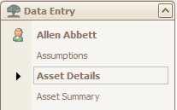

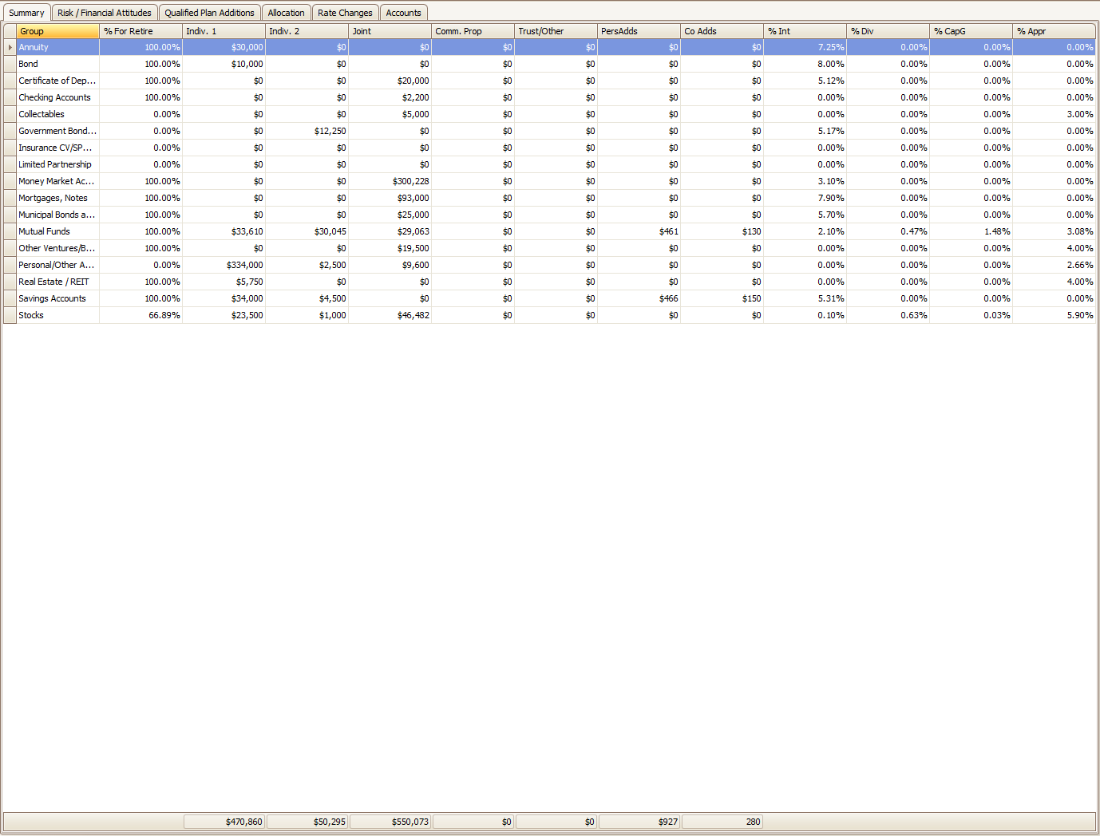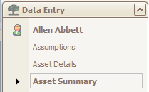

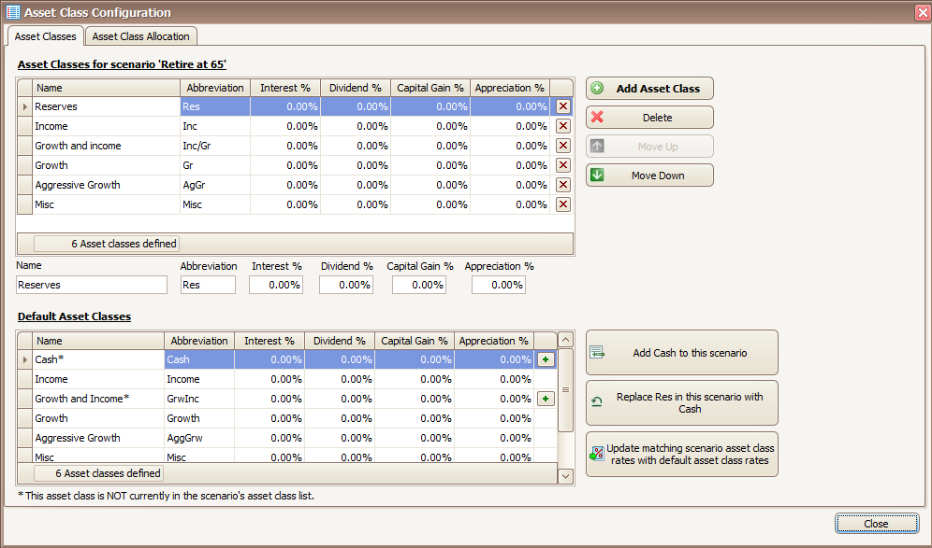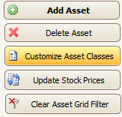While in a Scenario it is now easier to update Asset Classes with new Settings/Defaults information (such as updated rates of return or new asset classes).

The bottom half of the Customize Asset Classes screen shows the Default Asset Classes set up in the Settings/Defaults while the top half shows the Asset Classes for the selected scenario. Any Default Asset Classes not in the current scenario can be added through either the Add button or the + button on the individual line within the grid. In this case the name of the “Growth and Income” asset class has been updated in the Defaults so that this is seen as a different class than “Growth and income” (note the capitalization of Income between the two). In a case like this the Replace button will replace the line chosen in the top grid with the line chosen on the bottom grid. The two appropriate lines are noted on the button using their respective abbreviations.

If the only thing that has changed in the Default Asset Classes is the rates of return then the Update button can be used to quickly change all of the Scenario Asset Classes that are also in the Defaults to have the same rates of return as the Defaults.

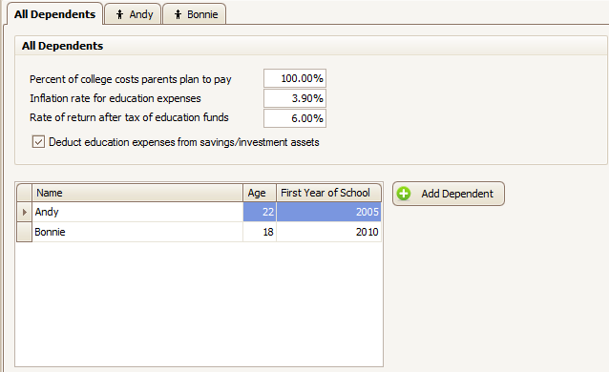**Dependents:**

The Dependents section now creates a separate tab for each of the up to eight dependents you enter in the system. If you want to delete a dependent select the tab for that dependent and click the Delete Dependent button.

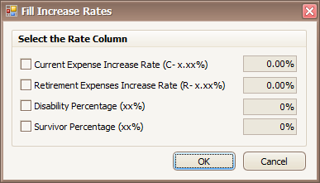 **Personal Expenses:**

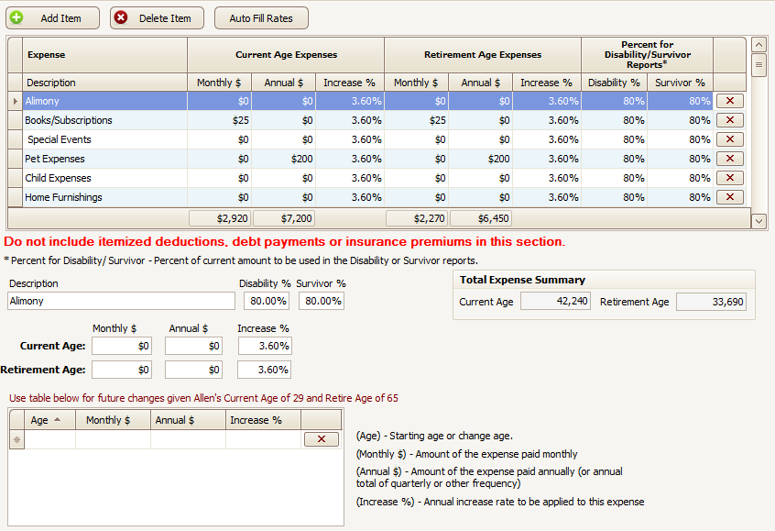In Personal Expenses the Auto Fill Rates button can now change multiple rates at the same time. Click on the Auto Fill Rates button, in the pop-up that appears check any of the rates that you would like to change, enter the new applicable numbers and click OK to apply the changes.